Q1) Create a procedure to display all records from department table

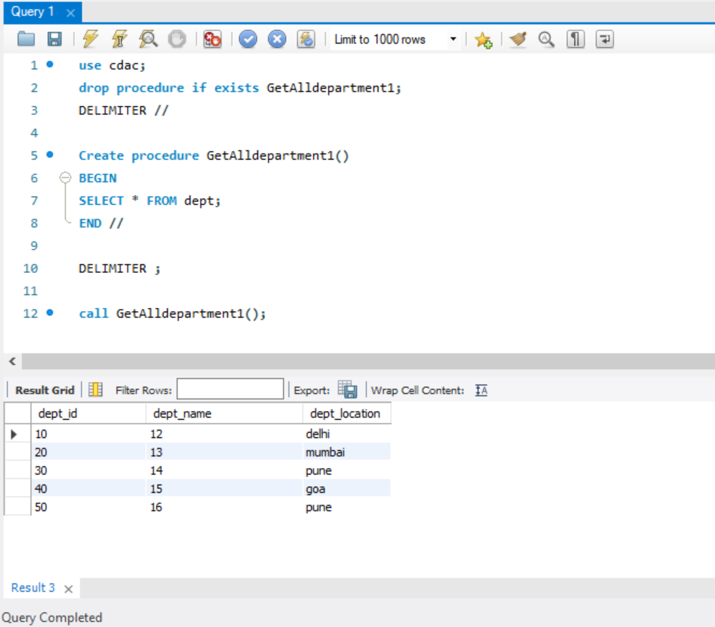

Q2) Create a procedure to return and display employe id, employee name, department

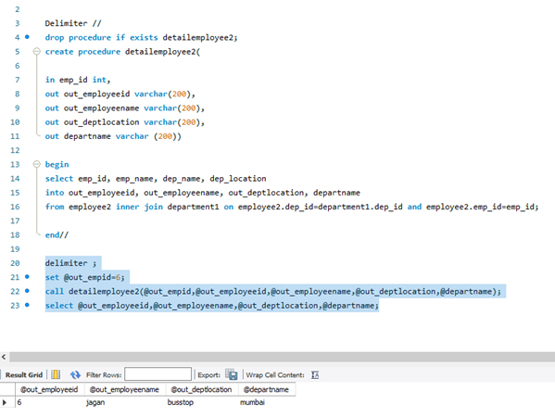

Q3) Create a copy of the table employee

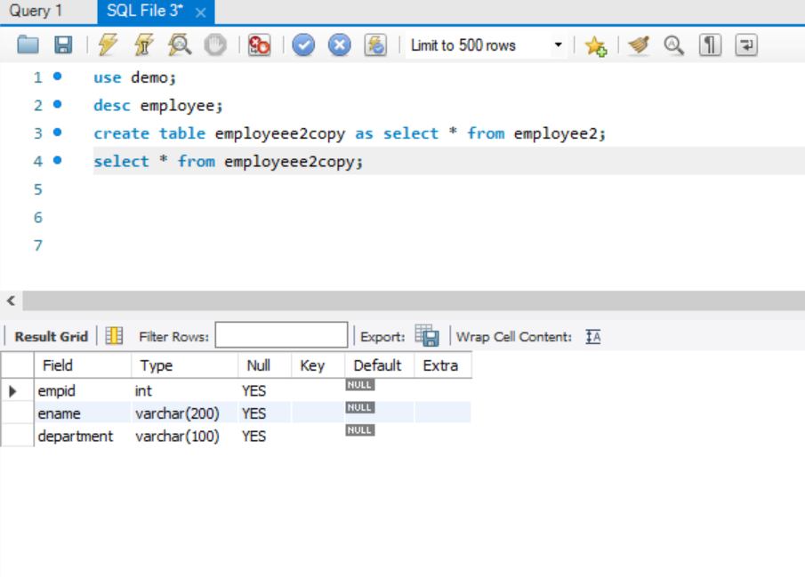

Q4) Create a procedure to move some records one by one from employee table to employee copy table for some selected departments using while/repeat /loop Ie write the same program with different looping structures.

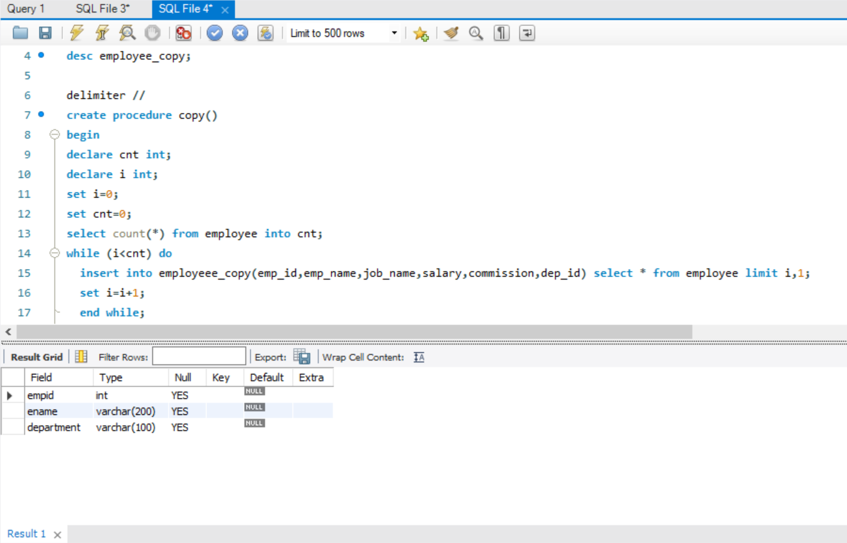

Q4) loop

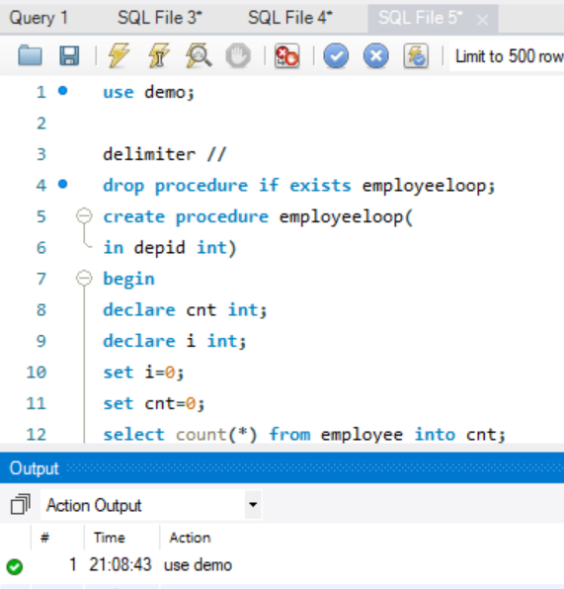

Q5) Create a procedure to delete the departments from department table by passing department id as the IN parameter which doesn’t have corresponding records in employee table.Use IF THEN END IF structure to check in employee table and ensure there is no childrecords . Department record to be deleted only if the employee table check is true.

